Name :

Abubaker Attique

Roll no :

P20-0560

Section :

5-A

Lab 09

.

Lab Task:

1. **What is the source and destination port numbers?**

**Answer :**

**Source port :60643**

**Destination port: 80**



1. **What is the sequence number of the TCP SYN segment that is used to initiate the TCP connection? What is it in the segment that identifies the segment as a SYN segment?**

Answer :

Sequence Number: 0

TCP Segment Len: 0

The value is 0 in this trace. The SYN flag is set to 1 and it indicates that this segment is a SYN,ACK segment.

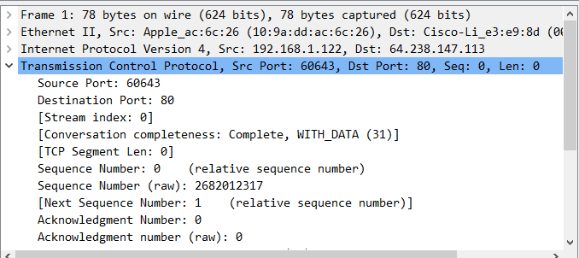

1. **What is the sequence number of the SYNACK segment sent by the server to the client computer in reply to the SYN? What is the value of the Acknowledgement field in the SYNACK segment? How did server determine that value? What is it in the segment that identifies the segment as a SYNACK segment?**

**Answer :**

**Acknowledgment Number = 1 (relative ack number)**

**Sequence Number (raw) = 349487776**

The server adds 1 to the initial sequence number of SYN segment form the client computer because window size is 1. For this case, the initial sequence number of SYN segment from the client computer is 0, thus the value of the Acknowledgement field in the SYNACK segment is 1.

Window = 5792

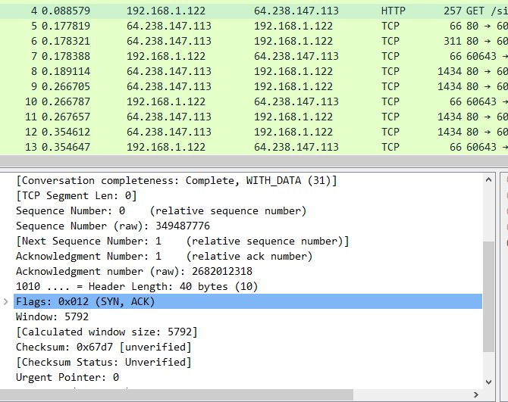

1. **What is the length of each of the first six TCP segments?**

Answer :

1:

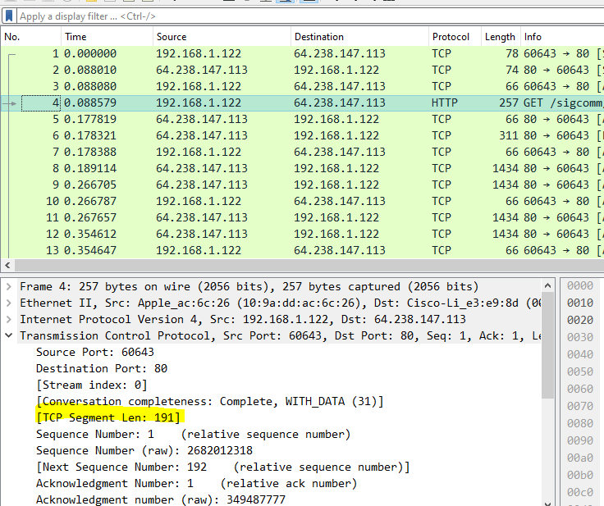

2:

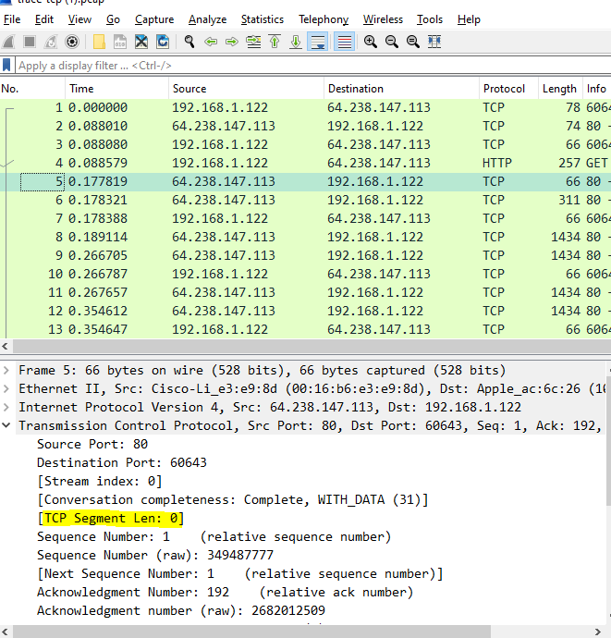

3:

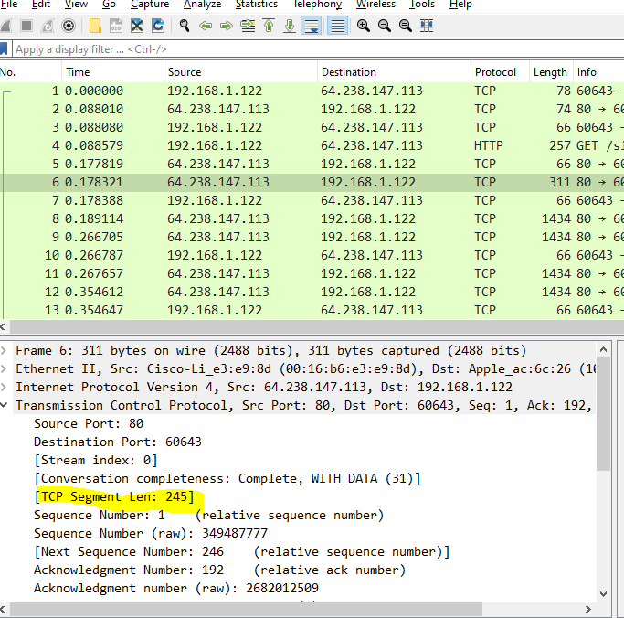

4:

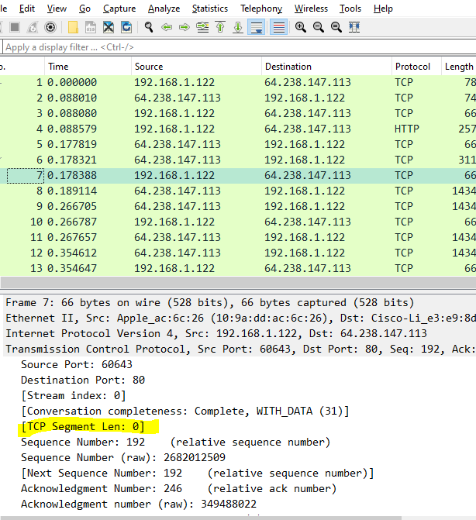

5:

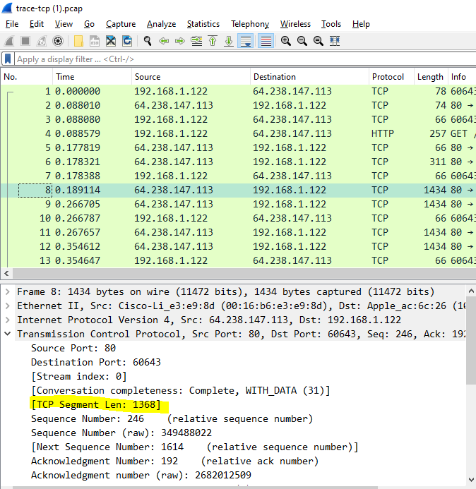

6:

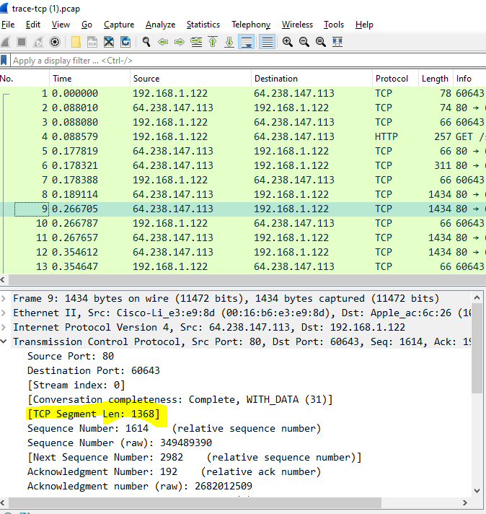

1. **Are there any retransmitted segments in the trace file? What did you check for (in the trace) in order to answer this question?**

Answer :

Yes there is retransmitted in packet 7 and packet 10 because the source and destination both are same in packets and the sequence number should also be same.

Packet 7:

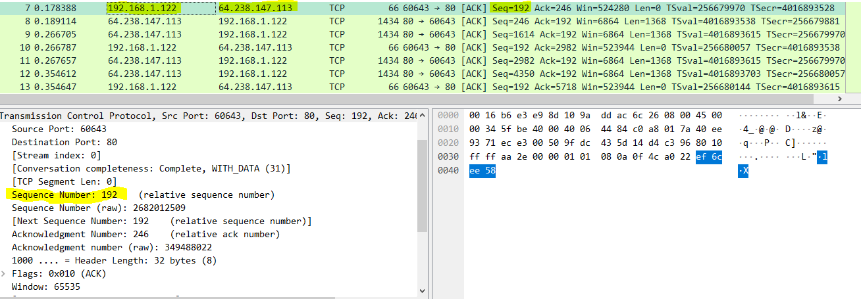

Packet 10

